 | NATIONAL ECOLABELLING PROGRAMME - GREEN CHOICE PHILIPPINES  Philippine Center for Environmental Protection and Sustainable Development, Inc.  Address: 3F Asian Pacific Corporate Center, 26 Harvard St. Brgy. Socorro, Cubao, Quezon City  STAKEHOLDER’S COMMENTS FOR NELP-GCP CRITERIA | 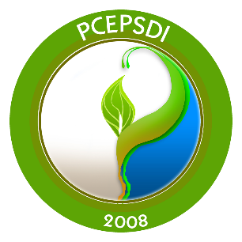

Document:
Date for Circulation
Due Date for Comments
Submitted by: | Name:
 | Position:
 | Institution:
 | Contact Number:
 | Email Address:
Clause No. / Sub-clause No. / Annex  (e.g. 3.1. Title) | Paragraph / Figure / Table / Note  (e.g. Table 1) | Type of Comment * | Proposed Change | Comment (justification for change) | Action/Remarks
*Type of Comment: ge = general te = technical ed = editorial

Please submit comments by email: greenchoicephilippines@pcepsdi.org.ph and brenda.butardo@pcepsdi.org.ph

